A Comparative Analysis of Inference Mechanisms Applied to Solving the Rush Hour Board Game.

Daniel Boden  School of Computing  Teesside University  P4048818@tees.ac.uk | Dean Duff  School of Computing  Teesside University  P4261930@tees.ac.uk | Jo Humphreys  School of Computing  Teesside University  P4048801@tees.ac.uk

Keywords: COM3036-N-BF1-2017 A Comparative Analysis of Inference Mechanisms Applied to Solving the Rush Hour Board Game.
Abstract

- Pretty much insert the ‘Focus’ from the picture here, thooooo, might be better to just mention what the paper will be looking into…..nah yeah, not the focus here but just a-well … abstract? (DB will probs do draft 1 of this)

This paper investigates a comparative analysis of A star and planner inference mechanisms, in providing solution’s to solving the Rush Hour board game. Papers such and MENTION PAPER HERE and MENTION PAPER HERE have similarly provided analysis of other types of sliding puzzles and board games. Discovering which inference mechanism provides the ‘best’ solution, will involve analysing multiple factors of the solutions provided, such as speed, cost, and efficacy. To allow the investigation to procced, Clojure versions of the A star and planner inference mechanisms will be found and extended upon. Then the environment for the Rush Hour board game will be designed and implemented via tuples into the Clojure environment for the inference mechanisms to interact with and modify, using operators that have conditions regarding the puzzles environment tuples. Extending upon the experiment tools and environment, a NetLogo based model will also be built that will provide a visual display of the puzzles environment, the Clojure inference mechanism will then interact with the NetLogo model using sockets to send commands. The NetLogo models visual display will provide another view on the solutions created, that can help expand upon the analysis performed on said solutions.
1. Introduction & Background

The Rush Hour board game was created by Nobuyuki “Nob” Yoshigahara’s, and is a puzzle base game in which players move vehicle pieces on the board to allow the target vehicle to reach the exit. The rules of the game are rather simple, vehicles placed onto a n x n grid can move either vertically both north and south, or horizontally east and west. The orientation of the vehicles, which are at a minimum of two grids spaces wide, determine which way the vehicle can move. However, vehicles can only move in their specified directions only if they are not blocked by either another vehicle or the maps walls.
With regards to the complexity of the puzzle talk about this:
http://www.sciencedirect.com/science/article/pii/S0304397501001736

https://en.wikipedia.org/wiki/Rush_Hour_(puzzle)
- Put the focus here? More or less?
- Talk about some simple background stuff on the rush hour game
- Talk about the rules for the rush hour game
- Mention how other papers have tackled the same type of problem before, and reference and briefly talk about them
2. Our Work
2.1. NetLogo
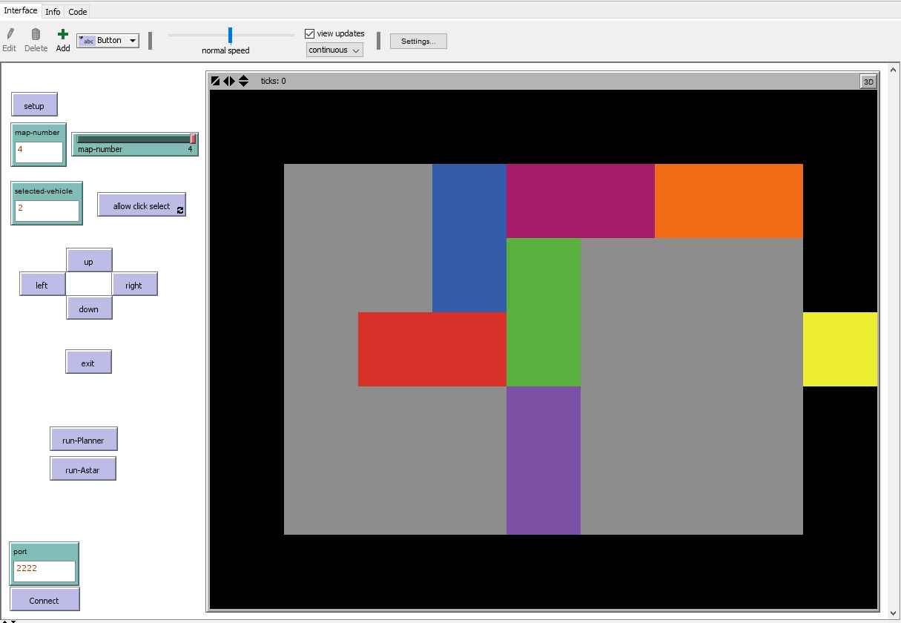
Fig 1. An image of the NetLogo model, depicting the environment in which the experiments were set up and ran with.
The Netlogo model was simple to set up with regards to the simple moving of the vehicles while catering for the Rush Hour puzzle rules. The Map was set to 8 x 6 patches, however the playable space for the vehicles to move in was 7 x 5 patches, due to a black wall surrounding the grey ‘Car park’ with a single yellow exit. Vehicles themselves were the only objects that changed in each map, different layouts of the vehicles represented different maps, the map size or the exit location did not change.

;players car
ask patch 2 3 [
set pcolor red
set vehicleNumber 1
set isvehiclefront true
set axis "x"
set axis-value 3
]
ask patch 1 3 [
set pcolor red
set vehicleNumber 1
set isvehiclefront false
set axis "x"
set axis-value 3
]

The above code snippet shows how an individual vehicle is represented in the NetLogo model, two patches are used for each vehicle both the same colour. The patches have a variable of vehicleNumber that are set to the same value to allow for easier selection of the ‘vehicle’ in the move procedures, isvehiclefront is used to help with the moving of the patches and detecting if a move is legal. Finally, the axis and axis-value are used to help the move procedures know if the vehicle can move vertically or horizontally, ‘x’ represents a vehicle that can move along the x-axis (horizontally) while ‘y’ can move along the y-axis (vertically). To reduce the variables on the patches and simplify the move procedures, the vehicle with a vehicleNumber of ‘1’ was always used to represent the ‘target’ vehicle which is the vehicle that needed to reach the exit.
2.2. Room/Map setup
To introduce complexity into the problem, various puzzle spaces were implemented. Ranging from a simple 2 vehicle space, where minimal moves were required to reach a goal state. To a more complex state including multiple vehicles, wherein vehicles were placed around the puzzle space in such a way that prevented other non-player vehicles from moving, which would then have a knock-on effect to other vehicles. Which made reaching the goal more difficult, as well as introducing a larger amount of possible legal moves to do so. As well as introducing complexity into the problem, it also allows the search algorithms to be run on a problem which would produce few move possibilities, which would drastically reduce the amount of time and moves taken to reach a goal state. This is useful for testing the algorithms and ensuring that the goal state has been reached as expected in a timely manner.
Initially, the problems were solved manually using an online version of the rush hour game. This was required to ensure that the problem spaces, which the algorithms would attempt to solve, would be able to achieve a goal state. As mentioned the first problem space which was implemented involved 2 vehicles. A 6x8 patch grid was provided to the algorithms (Fig 2.) with the player car placed adjacent to the goal patch, with a non-player vehicle obstructing the player vehicles path. With this setup there would only be 2 possible states which could be achieved, both of which would clear the obstruction to the player vehicle, subsequently allowing the player vehicle to reach the goal.
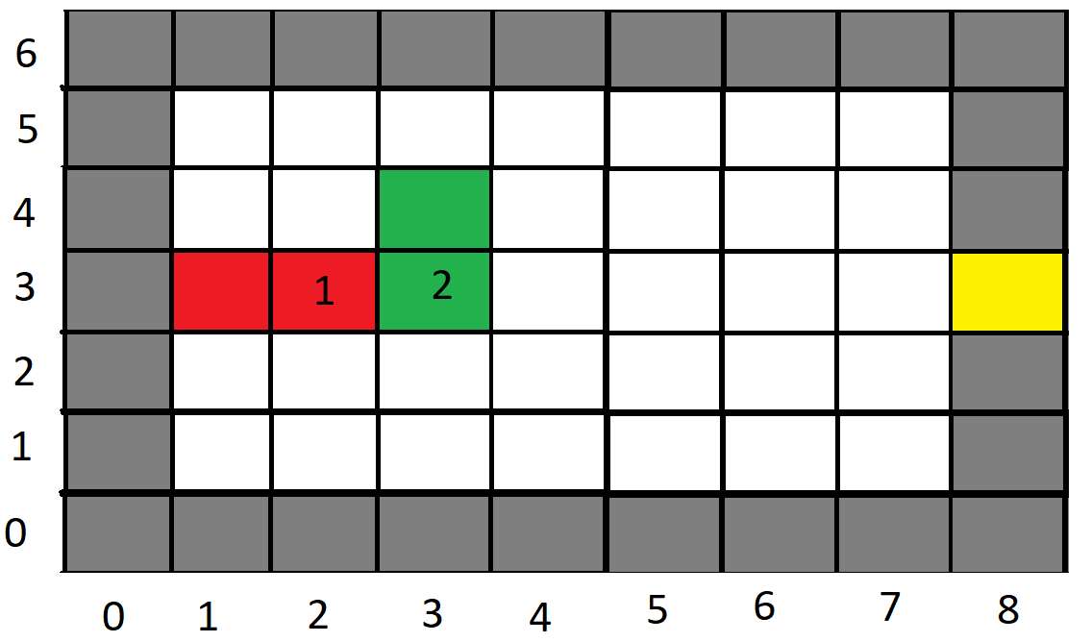
Fig 2. Example of the simple puzzle space which was implemented.

To increase complexity in the puzzle space more cars were added, each utilising various directions of movement. The iteration of the problem which followed the basic example used the same sized 6x8 patch grid. By doing so it allowed for additional scenarios to be carried out. One of which was a scenario that allowed the goal state to be reached by granting the other non-player vehicles freedom to move in multiple directions to achieve the goal state as demonstrated in the puzzle space in Fig 3. To achieve the goal state, it requires non-player vehicle 2 and 3 to be moved vertically to clear the path. For this vertical movement to be possible it requires the horizontal movement of non-player cars 4 and 5 which are restricting the essential vertical movement of vehicles 2 and 3.
What is interesting about this scenario, is that there are multiple ways which the horizontal and vertical movements can be executed, as well as multiple ways for the goal to be reached. With each search algorithm implementing different methods of reaching a goal state, it would be expected for each to achieve the goal in their own way. Once all the results and moves made for each respective algorithm are returned, it would be possible to perform analysis on how each algorithm successfully got the player car to the goal. For example, vehicle 5 can be moved to the leftmost patch, allowing vehicles 2 and 3 to move into the now free space, subsequently clearing a path of the player vehicle to reach the goal. Alternatively, each of the horizontal non-player vehicles could move a single patch, which would, in turn, allow the nearest vertical non-player vehicle to each move into the space created by the aforementioned vehicles. Which would then create a clear path for the player vehicle to reach the goal.
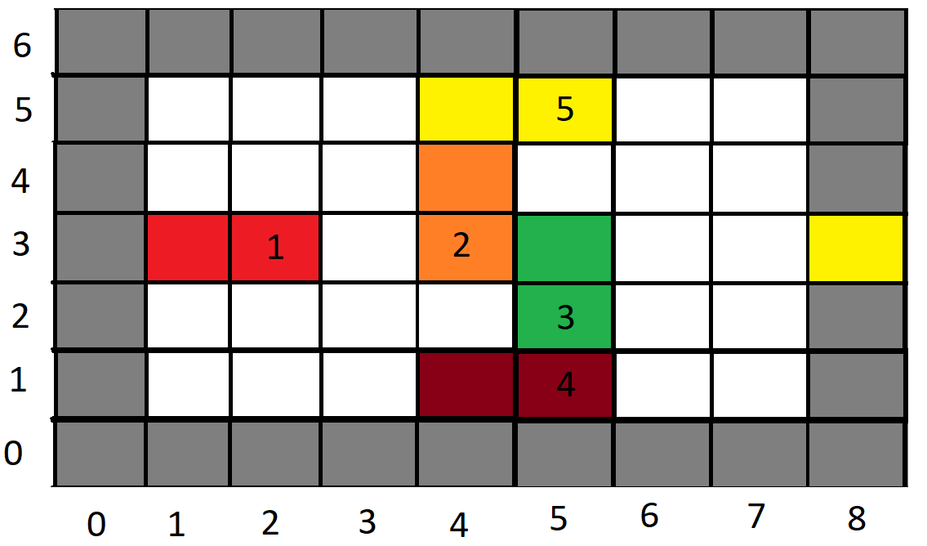
Fig 3. Example of the puzzle space where the goal can be reached using multiple techniques.

To further increase the complexity of the puzzle, additional puzzle spaces were implemented which would require movement of the player car in more than one direction as demonstrated in Fig 4. This would increase the complexity by making it necessary for the player car to move incrementally, to clear spaces for non-player vehicles. Again, this could achieve some interesting results as the player vehicle may need to move away from the goal, which may appear counterproductive to reaching the goal. As well as making the puzzle more complex in some cases, as the player car could move away from the goal state and subsequently block and further movement. This would greatly increase the number of non-player movements required as the additional move would be required whenever this may occur. Due to the nature of each algorithm, it would be interesting to see how they would deal with the back-tracking element of the puzzle.
The puzzle space (Fig 4.) demonstrates where backtracking would need to occur as there are no possible moves available for non-player vehicles. The non-player vehicle 3 is blocking the path for the player vehicle, but the vehicle is itself blocked in both directions, by vehicles 2 and 5. The first move required to achieve movement towards the goal would be for vehicle 1 (the player vehicle) the move away from the goal, which in turn would allow the movement vehicle 4, which would create further legal moves for the remaining non-player vehicles.
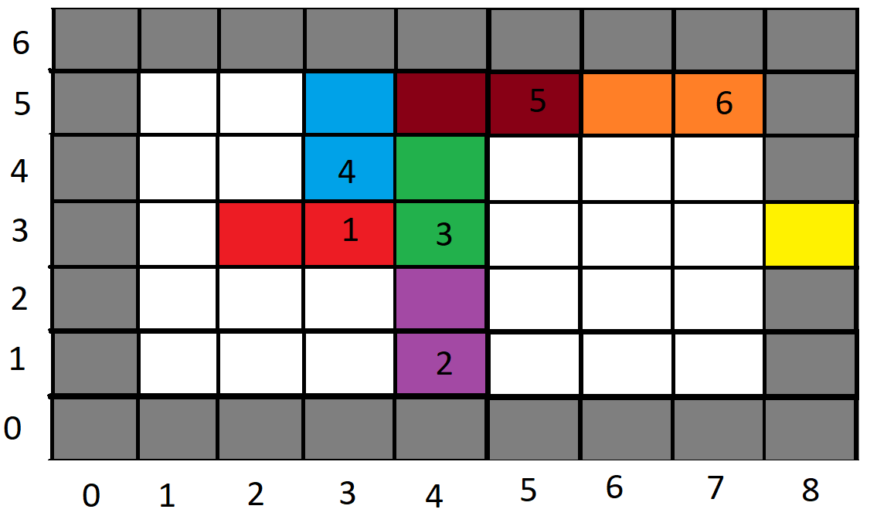
Fig 4. Example of the puzzle space where backtracking is required.
To allow the search algorithms to find a solution to each of the problems, the puzzle spaces would require mapping into tuples. These tuples would represent a world state which would mirror that of the puzzle spaces used to identify the different scenarios that would be experimented upon. To achieve the correct representation of the world space, the tuples would implement a wall surrounding the world space as demonstrated by the grey areas surrounding the grid in Figure 4. One of these patches would be used as a goal patch. By doing so enforces a rule, wherein no vehicles in the puzzle can cross, or move into any of these patches. With the exception of the goal patch, that the player vehicle can move into, which results in a goal state.
Tuples are defined in Clojure by mapping a 1:1 copy of the puzzle spaces, by first defining the size of the puzzle space which is being solved. Then assigning all the patches within the space a definition, for example, walled patches, vehicles, and goal patches. The below snippet of Clojure code is an example of the representation of a puzzle space as a tuple. Which shows that the world state uses a 7x5 grid of patches, followed by the assignment of patches used for walled areas, as well as free spaces that vehicles can move into.

(list 'max-size 7 5)
;;y 0 wall
;(list 'at 0 0 'none)
;(list 'at 1 0 'none)
;(list 'at 2 0 'none)
;(list 'at 3 0 'none)
;(list 'at 4 0 'none)
;(list 'at 5 0 'none)
;(list 'at 6 0 'none)
;(list 'at 7 0 'none)
;(list 'at 8 0 'none)
;;y 1
;(list 'at 0 1 'none) wall

When assigning patches, which would represent vehicles and the goal patch. This is achieved similarly to assigning walled areas and free space, but the vehicles orientation, colour, and type of patch. By doing so eliminates any illegal movement of vehicles, as when an orientation is defined, it forces the vehicle to move solely along a single axis. The goal patch is defined as a single patch, this is required for defining the completion of the puzzle. As the player vehicle needs to reach this patch for a puzzle to be solved. Below is another snippet of code, which demonstrates the implementation of a goal patch, as well as the player vehicle with all its properties assigned.

;;goal
(list 'isa 8 3 'goal)

;;player vehicle
(list 'isa 'pv 'vehicle)
(list 'colour 'pv 'red)
(list 'orientation 'pv 'horiz)
(list 'at 3 3 'pv)
(list 'at 2 3 'pv)
(list 'clear-me 2 3 'pv)
2.3. A*/Breath first Algorithms
- Talk about how it was made (LOOK AT PITCH 2)
- Talk about how removing rules from the A* Algorithm transforms it into a simple ‘Breath first’ algorithm.
2.4. Planner Algorithm
- Talk about how it was made (LOOK AT PITCH 2)
- Go into the operators chosen and talk about why
3. Results
3.1. A* experiments
The A* experiments were executed within a lein repl using the following command:
(time (pprint (A*search {:state test-world1 :cost 0} (fn [x] (contains? x '(at 8 3 pv))) lmg)))
‘test-world1’ was replaced with the number of the map to be tested before the execution of the command. The cost used for the A* experiments was a simple cost of 2 for vertical moves and a cost of 1 for horizontal moves, the idea behind this cost design was due to how the player car can olny move horizontally towards the exit not vertically, thereby making it so that moving the player car towards the exit was prioritized to an extent.

Solutions created:

Map 1
:txt ((npv2 moves to 3 5))
:txt ((pv moves to 3 3))
:txt ((pv moves to 4 3))
:txt ((pv moves to 5 3))
:txt ((pv moves to 6 3))
:txt ((pv moves to 7 3))
:txt ((pv moves to 8 3))

Map 2
((npv4 moves to 3 1))
((npv3 moves to 5 1))
((npv5 moves to 6 5))
((npv2 moves to 4 5))
((pv moves to 3 3))
((pv moves to 4 3))
((pv moves to 5 3))
((pv moves to 6 3))
((pv moves to 7 3))
((pv moves to 8 3))

Map 3
:txt ((pv moves to 1 3))
:txt ((npv4 moves to 3 3))
:txt ((npv5 moves to 3 5))
:txt ((npv5 moves to 2 5))
:txt ((npv3 moves to 4 5))
:txt ((npv5 moves to 1 5))
:txt ((npv4 moves to 3 5))
:txt ((pv moves to 3 3))
:txt ((pv moves to 4 3))
:txt ((pv moves to 5 3))
:txt ((pv moves to 6 3))
:txt ((pv moves to 7 3))
:txt ((pv moves to 8 3))

Compiled Results:

Map | Moves Made | Test1 (seconds) | Test2 (seconds) | Test3 (seconds) | Test4 (seconds) | Test5 (seconds) | Average time taken (seconds)
1 | 7 | 1.41 | 1.04 | 0.98 | 0.94 | 1.02 | 1.08
2 | 10 | 457.46 | 1038.58 | 1550.48 | 313.26 | 684.68 | 808.89
3 | 13 | 11.13 | 13.22 | 15.69 | 18.38 | 21.5 | 15.99

Notes:
- Each run of the A* algorithm used up around 35% of the CPU of the test machine and 2.5 – 3GB’s of ram while executing.
Review:
The A* algorithm tests ran against the maps shown in figures 2-4, ran with few problems, the time taken for the simple map 1 and the back-tracking map 3 were both reasonably fast and produced solutions that were within our expectations. A considerable amount of time however was spent on solving map 2, which was not expected. All solutions produced found the shortest possible route for all the maps, and the movements made in them solutions looked reasonably well structured and logical, with no unnecessary or inefficient moves made.
From looking further into what the cause of the exponential increase of the time taken in experiments performed for map 2, it can be assumed that both the loose placement of the vehicles on the map causing multiple valid solutions to be possible and the poor cost implementation for the A* algorithm could be the cause.

3.2. Breadth First experiments

The Breadth First experiments were executed within a lein repl using the following command:
(time (pprint (A*search {:state test-world1 :cost 0} (fn [x] (contains? x '(at 8 3 pv))) lmg)))
‘test-world1’ was replaced with the number of the map to be tested before the execution of the command. Due to the A* search algorithm being an extension of a simple Breadth First search algorithm with cost implemented, to run tests with a Breadth First algorithm the costs for all moves was set to 1, thereby nullifying the impact of cost.

Solutions created:

Map 1
:txt ((npv2 moves to 3 5))
:txt ((pv moves to 3 3))
:txt ((pv moves to 4 3))
:txt ((pv moves to 5 3))
:txt ((pv moves to 6 3))
:txt ((pv moves to 7 3))
:txt ((pv moves to 8 3))

Map 2
:txt ((pv moves to 3 3))
:txt ((npv4 moves to 3 1))
:txt ((npv5 moves to 6 5))
:txt ((npv3 moves to 5 1))
:txt ((npv2 moves to 4 5))
:txt ((pv moves to 4 3))
:txt ((pv moves to 5 3))
:txt ((pv moves to 6 3))
:txt ((pv moves to 7 3))
:txt ((pv moves to 8 3))

Map 3
:txt ((pv moves to 1 3))
:txt ((npv4 moves to 3 3))
:txt ((npv5 moves to 3 5))
:txt ((npv5 moves to 2 5))
:txt ((npv5 moves to 1 5))
:txt ((npv3 moves to 4 5))
:txt ((npv4 moves to 3 5))
:txt ((pv moves to 3 3))
:txt ((pv moves to 4 3))
:txt ((pv moves to 5 3))
:txt ((pv moves to 6 3))
:txt ((pv moves to 7 3))
:txt ((pv moves to 8 3))

Compiled Results:

Map | Moves Made | Test1 (seconds) | Test2 (seconds) | Test3 (seconds) | Test4 (seconds) | Test5 (seconds) | Average time taken (seconds)
1 | 7 | 2.91 | 2.35 | 2.26 | 2.29 | 2.39 | 2.44
2 | 10 | 1480.06 | 2487.92 | 752.68 | 1935.65 | 1037.7 | 1538.8
3 | 13 | 26.84 | 37.48 | 49.97 | 62.83 | 71.91 | 49.81

Notes:
- Each run of the Breadth First algorithm used up around 40% of the CPU of the test machine and 3.5 – 4GB’s of ram while executing.

Review:
The Breadth First modification to the A* algorithm, ran all the tests without any errors or problems, however the time taken for tests on map 3 and especially map 2 were very long, with an average time of 25 minutes for the algorithm to complete a solution to map 2. As stated in the notes section of the Breadth First tests, the ram usage for the tests climbed up to and above 4GB’s, for some of them test. Again, however all solutions produced found the move efficient number of moves for the selected maps, and the steps produced appear to be logical and without any unnecessary/wasted movements.

3.3. Planner experiments

The planner experiments were executed within a lein repl using the following command:
(time (pprint (:txt (planner test-world1 (list 'at 8 3 'pv) primary-ops))))
‘test-world1’ was replaced with the number of the map to be tested before the execution of the command.

Solutions created:

Map 1
((npv2 moves to 3 5)
(pv moves to 3 3)
(pv moves to 4 3)
(pv moves to 5 3)
(pv moves to 6 3)
(pv moves to 7 3)
(pv moves to 8 3))

Map 2
((npv5 moves to 6 5)
(npv5 moves to 7 5)
(npv3 moves to 5 4)
(npv3 moves to 5 5)
(npv2 moves to 4 5)
(pv moves to 3 3)
(pv moves to 4 3)
(pv moves to 5 3)
(pv moves to 6 3)
(pv moves to 7 3)
(pv moves to 8 3))

Map 3 FAIL
(:dbg GOALS:)
(:dbg (at 7 5 npv6))
(:dbg (cleared 7 5 npv6))
(:dbg (at 0 5 npv6))
(:dbg (cleared 7 5 npv6))
(:dbg (at 7 5 npv5))
(:dbg [branch-horiz :=> (at 7 5 npv5)])
(:dbg [branch-horiz :=> (at 7 5 npv5)])
(:dbg [branch-horiz :=> (at 7 5 npv5)])
(:dbg [branch-horiz :=> (at 7 5 npv5)])
(:dbg [branch-horiz :=> (at 7 5 npv5)])
(:dbg [branch-horiz :=> (at 7 5 npv5)])
(:dbg [branch-horiz :=> (at 7 5 npv5)])
(:dbg [branch-horiz :=> (at 7 5 npv5)])
(:dbg [branch-horiz :=> (at 7 5 npv5)])
(:dbg [branch-horiz :=> (at 7 5 npv5)])
(:dbg [branch-horiz :=> (at 7 5 npv5)])
(:dbg [branch-horiz :=> (at 7 5 npv5)])
(:dbg [branch-horiz :=> (at 7 5 npv5)])
(:dbg [branch-horiz :=> (at 7 5 npv5)])
(:dbg [branch-horiz :=> (at 7 5 npv5)])
(:dbg [branch-horiz :=> (at 7 5 npv5)])
(:dbg [branch-horiz :=> (at 7 5 npv5)])
(:dbg [branch-horiz :=> (at 7 5 npv5)])
(:dbg [branch-horiz :=> (at 7 5 npv5)])
(:dbg [branch-horiz :=> (at 7 5 npv5)])
(:dbg [branch-horiz :=> (at 7 5 npv5)])
(:dbg (cleared 4 5 npv5))
(:dbg (at 0 5 npv5))
(:dbg (cleared 4 5 npv5))
(:dbg (at 4 5 npv3))
(:dbg [branch-horiz :=> (at 4 5 npv3)])
(:dbg (cleared 4 3 npv3))
(:dbg (at 4 0 npv3))
(:dbg (cleared 4 3 npv3))
(:dbg (at 4 3 pv))
(:dbg [branch-vert :=> (at 4 3 pv)])
(:dbg [move-horiz :=> (at 5 3 pv)])
(:dbg [move-horiz :=> (at 6 3 pv)])
(:dbg [move-horiz :=> (at 7 3 pv)])
(:dbg [move-horiz :=> (at 8 3 pv)])
(:dbg ------)

Compiled Results:

Map | Moves Made | Test1 (seconds) | Test2 (seconds) | Test3 (seconds) | Test4 (seconds) | Test5 (seconds) | Average time taken (seconds)
1 | 7 | 2.24 | 2.87 | 2.23 | 2.18 | 2.09 | 2.32
2 | 11 | 3.25 | 3.34 | 3.48 | 3.54 | 3.81 | 3.48
3 | N/A | N/A | N/A | N/A | N/A | N/A | N/A

Notes:
- Map 3 failed to run and hit a Runtime Exception, in which a limit was breached while searching for a solution, the code snippet for map 3 is from a latter section of the pretty printed command. It shows a problem solving the movement of npv5 (non-player vehicle) seems to have been the cause of the error.
- Each run of the Planner algorithm used up around 40-47% of the CPU of the test machine and 2GB’s of ram while executing.

Review:
The Planner algorithm tests executed in under 3.5 seconds for most tests, but some problems occurred during back-tracking map 3 tests that prevented data from being recorded from the tests, and for the very open and multiple viable solutions map 2, inefficient moves were made. The map 3 error that occurred can be understood from the snippet of code provided showing an instance of the goal stack near the latter end of the algorithm before it errored out, in which vehicle 5 was targeted as needing to be moved so vehicle 3 could move, but vehicle 4 was not seen as a vehicle that should/could be moved making it so that no solution for moving vehicle 5 could be found leading to a runtime exception.
Finally, the inefficient movement can be seen in map 2’s solution, were vehicle 5 is moved all the way to the top right of the map, for the vehicles 2 and 3 to then move upwards to move out of the way of the player vehicle 1. Though this inefficiency is only one move extra than the minimum number of moves, on more complex puzzles this could prove exponentially larger, due to there being no cost for moved made and due to the focus of the planner algorithm being to find a solution not necessarily the most efficient one.
4. Analysis & Conclusion
4.1. Analysis
From the analysis performed upon the compiled and raw results of the three algorithms, it appears no clear algorithm performs the tests without some serious problems/flaws. The Breadth first algorithm is as expected the most time consuming of all the algorithms with an average time of 25 minutes to complete is most problematic test, which was map 2. The A* algorithm performed better than the breadth first algorithm by completing most of its tests nearly 50% faster than the Breadth First algorithm, map 2 for example only took 13 minutes on average to complete. The A* algorithm however still took longer than expected to complete the map 2 and map 3 tests, especially the map 2 test, it appeared that the cost implemented in the algorithm help significantly, but as to be expected of a breadth first based algorithm, scaling is its weak point. The Planner algorithm proved to be the fastest algorithm for providing solutions to the map problems, the times taken for most of the maps as previously mentioned were on average under 3.5 seconds. This speed of the Planner algorithm almost made it the unquestionably best algorithm for the Rush Hour puzzle, but multiple flaws prevented it from being a clean-cut answer/solution to the problem. A minor flaw with the algorithm was its lack of focus on finding the most efficient solution to solving a map, as mentioned in the results shown for the solution of map 2, a very curious and slightly inefficient solution was created a solution that wouldn’t be an obvious solution to a human. The major flaw with the planner algorithm however, was its failure to be able to solve map 3, the map designed with back-tracking the player vehicle in mind. It had already been discovered and mentioned that the problem relied on the Planner algorithm calculating how to clear the map from right to left and in doing so when trying to clear vehicle 3 then vehicle 5, vehicle 4 was not considered/seen as a vehicle that required moving.
To summarize, the Breadth first search algorithm will be able to provide solutions to all Rush hour maps that could be created going forward, at an exponentially large cost of time to find said solutions. The A* algorithm similarly to the Breadth First algorithm could also provide solutions to all the potential rush hour maps, with a high chance of the most efficient solutions being found, time taken for finding the solutions however can still have the potential to scale to large numbers even with the algorithm being 50% faster than the Breadth First algorithm. Finally, the planner algorithm in its current state cannot be relied on to be able to provide solutions for any current or future Rush Hour map and cannot, like the Breadth First algorithm, be relied upon to always find an efficient solution. It should be noted however that the speed at which the Planner could solve some of the Rush Hour maps was much faster than any of the other two algorithms, and even upon attempting a map problem that it will fail upon, it will fail fast.
With the information gathered from the experiment results and analysis of the data from the results, it appears the best and most reliable algorithm for solving the Rush Hour puzzle is the A* algorithm. It is the second fastest algorithm for solving the puzzle and though multiple solutions to a Rush Hour puzzle are possible, the solution with the least number of moves is the ‘correct’ solution, thereby making the A* algorithm the most suitable due to its use of cost to find an efficient solution instead of just a solution.
4.2. Conclusion
Although some flaws were found within the Planner algorithm upon executing the experiments, the results and analysis performed on said results for all the algorithms were conclusive and informative and lead to the A* algorithm being chosen as the currently best algorithm for the Rush Hour puzzle. However, both the A* and the Planner algorithms were lacking in certain ways, which may have slightly changed the conclusion reached in the analysis section of the report.
The A* algorithm was implemented with no problems, but the cost implementation used for the algorithm was very simple, potentially too simple and if a more advanced version of a cost was implemented the algorithm could have further decrease in the time required to find solutions.
The Planner algorithm however had many problems, the fact that it didn’t find the most efficient solution was expected due to the nature of how it calculated solutions, but its inability to solve some Rush Hour puzzles was rather disappointing. The speed at which some of the Planner compatible problems were solved was impressive and was one of the strongest values of the algorithm. With the solution finding speed that it has, it could still be used as the first algorithm to run on a Rush Hour puzzle before using the A* algorithm, if the goal is to find a solution fast that isn’t necessarily efficient.
Inconclusion, the experiments and tests could be expanded upon, with improved versions of the current algorithms alongside different algorithms that could be used to see if they are an improvement on the A* algorithm.

- Reflect on what went well, what could have gone better and what you think about the results/analysis we came to. Are they surprising, were they similar to other experiments done in other papers?

6. References

